**COMMUNITY AND SPECIAL SCHOOLS:**

**A JOURNEY OF INCLUSION**

**A COMMUNITY CONNECT PROJECT REPORT**

Submitted by

E.G.PRADEEP (RA2211004050026)

P.SURRYA DURAI (RA2211003050094)

S.S.ZAMEER BASHA (RA2211003050071)

**BACHELOR OF TECHNOLOGY**

**ELECTRONIC AND COMMUNICATION ENGINEERING**



**SCHOOL OF COMPUTING**

**FACULTY OF ENGINEERING AND TECHNOLOGY**

**SRM INSTITUTE OF SCIENCE AND TECHNOLOGY**

**TIRUCHIRAPPALLI – 621105**

AUGUST 2024

**SRM INSTITUTE OF SCIENCE AND TECHNOLOGY**

**TIRUCHIRAPPALLI**

**COLLEGE OF ENGINEERING AND TECHNOLOGY**



TIRUCHIRAPPALLI

**REGISTER NO.____________________________**

**BONAFIDE CERTIFICATE**

Certified as the bonafide record of work done by ____________________________________________________________, Register No. _______________________­­_________________ of _____________(Semester/Year), B.Tech. __________________________________________________________________ Programmein the project-based course **21GNP301L, Community Connect** at **SRM Institute of Science and Technology, Tiruchirappalli** during the Academic Year 2024-2025.

**Faculty In-charge Head of the Department**

Submitted for the End Semester Examination held on _________________

**Examiner 1 Examiner 2**

###### PROBLEM STATEMENT

Mr.Venkateshwara babu, a 56-year-old resident of our visited NGO, is facing significant challenges due to his disability. Having lost both his legs to diabetes, Mr. Ramesh's mobility is severely compromised, making him highly susceptible to falls. Despite using a wheelchair, his risk of falling remains high, posing a serious threat to his physical safety and overall well-being. The NGO's current infrastructure lacks an effective fall detection and response system, exacerbating the issue.Falls among elderly individuals with disabilities like Mr.Venkateshwara babu are not only physically dangerous but also have profound psychological impacts. The fear of falling again creates a vicious cycle of anxiety, leading to reduced mobility and social isolation. This emotional distress further diminishes their quality of life, making it imperative to address both the physical and mental health aspects.Currently, the NGO's response to falls is reactive rather than proactive. Caregivers often discover falls only after they occur, leading to delays in medical intervention that can result in severe complications. Furthermore, the lack of tailored support for individuals with unique needs like Mr. Venkateshwara babu highlights a critical gap in our care system.To address these challenges, it is essential to develop and implement a comprehensive fall detection and prevention system. This system should include wearable technology capable of monitoring movement patterns, detecting falls, and promptly alerting caregivers. Integration with the existing care infrastructure will ensure swift medical response, reducing the risk of severe injuries. Additionally, such technology can help restore confidence and independence to residents like Mr. Venkateshwara babu, improving their psychological well-being and encouraging social interaction.

###### TABLE OF CONTENTS

###### CHAPTER NO. TITLE PAGE NO. PROBLEM STATEMENT iii

###### LIST OF TABLE 3

###### LIST OF FIGURES 5

###### 

###### INTRODUCTION 7

|  |  |  |  |
| --- | --- | --- | --- |
| 1.1 | | RELEVANCE TO SGD | 7 |
| 1.2 | | LEVEL OF INNOVATION | 8 |
| 1.3 | | COMMUNITY WORK AND THE NGO | 8 |
| 1.4 | | MILESTONES AND TIMELINES | 9 |
| **2.** | **DESIGN AND DEVELOPMENT** | | **11** |
|  | 2.1 TECHNICAL IMPLEMENTATION | | 11 |
|  | 2.2 DELIVERABLES | | 13 |
|  | 2.3 BUDGET | | 15 |
|  | 2.4 IMPACT ASSESSMENT PLAN | | 16 |
|  |  | |  |
| **3.** | **CONCLUSION AND FUTURE WORK** | | 17 |
|  | 3.1 CONCLUSION | | 17 |
|  | 3.2 FUTURE WORK | | 17 |
| **4.** | **APPENDICES AND REFERENCES**  4.1 APPENDICES | | 18 |
|  | 4.2 REFERENCES | | 20 |
|  |  | |  |

LIST OF TABLES

|  |  |  |
| --- | --- | --- |
| TABLE NO. | TITLE | PAGE NO. |
|  |  |  |
| 1 |  | 8 |
| 2 |  | 17 |
| 3 |  | 19 |
| 4 |  | 20 |

LIST OF FIGURES

|  |  |  |
| --- | --- | --- |
| FIGURE NO. | TITLE | PAGE NO. |
|  |  |  |
| 1 |  | 8 |
| 2 |  | 17 |
| 3 |  | 19 |
| 4 |  | 20 |

**1.INTRODUCTION**

**1.1RELEVANCE TO SDG**

This project comes under the SDG goal No.3 Good Health and Wellbeing. The development and implementation of fall detection systems with automatic alerts to caregivers or emergency services are directly aligned with SDG 3, which aims to ensure healthy lives and promote well-being for all at all ages. Here’s how this project relates to specific targets under SDG 3. Fall detection systems help prevent injuries and complications from falls, which are a significant health risk for older adults and individuals with certain health conditions. By reducing the incidence and severity of falls, these systems contribute to lowering the burden of non-communicable diseases and promoting mental well-being, as the fear of falling can lead to anxiety and reduced physical activity. While this target primarily addresses environmental health risks, the integration of smart technology in homes to prevent falls can be seen as part of a broader effort to create safer living environments, thus reducing the risk of injuries and associated illnesses.

Fall detection systems enhance the capacity to manage health risks by providing early warning and rapid response capabilities. This is particularly important for older adults who live alone or in remote areas, as it ensures they receive prompt assistance in case of a fall.

**1.2LEVEL OF INNOVATION**

The fall detection system for disabled elderly people represents a remarkable innovation within the framework of the Sustainable Development Goals (SDGs). This project primarily aligns with SDG 3 (Good Health and Well-being), but also contributes to SDG 9 (Industry, Innovation, and Infrastructure) and SDG 11 (Sustainable Cities and Communities). The integration of advanced technologies such as wearable devices, the Internet of Things (IoT), and artificial intelligence (AI) stands at the forefront of this initiative. Wearable devices equipped with accelerometers and gyroscopes provide precise fall detection, while AI algorithms analyze movement patterns to predict and prevent falls. This innovative combination ensures a high degree of accuracy and reliability in monitoring the health and safety of elderly individuals.One of the most groundbreaking aspects of this project is real-time monitoring and immediate response. The system instantly alerts caregivers and medical personnel upon detecting a fall, significantly reducing response times and potentially saving lives. Geo-fencing capabilities add an extra layer of security by monitoring movements within designated safe zones. Integration with emergency services ensures that medical help is rapidly dispatched when needed, bridging a critical gap in current care systems.Customization and personalization further elevate the system’s innovation. Each user can tailor sensitivity settings based on their specific health conditions and mobility patterns. The system also adapts over time, learning from the individual’s behavior to improve detection accuracy and minimize false alarms. This personalized approach enhances user experience and ensures that the system meets the unique needs of each elderly individual.Holistic health monitoring is another key feature. The system not only detects falls but also monitors other vital health metrics such as heart rate and blood pressure. Predictive analytics use this data to foresee potential health issues, enabling preventive measures. This comprehensive health monitoring promotes overall well-being and proactive healthcare management.By significantly reducing the risk and fear of falls, this project improves the quality of life for elderly individuals, allowing them to regain confidence and independence. It also has a positive social impact, as it reduces healthcare costs and resource utilization through prevention and timely intervention. This innovative fall detection system exemplifies how technology can be harnessed to create inclusive, sustainable, and health-focused communities.

**1.3Community Work and NGO**

Community work and non-governmental organizations (NGOs) play a crucial role in developing and implementing fall detection systems for disabled individuals, particularly the elderly. Falls are a significant health risk, often leading to severe injuries and a loss of independence. Addressing this issue requires a multi-faceted approach involving technology, community support, and dedicated efforts from NGOs.Firstly, NGOs are instrumental in raising awareness about the importance of fall detection systems. They conduct educational programs to inform caregivers, disabled individuals, and the general public about the risks of falls and the benefits of using detection systems. These programs often include workshops, seminars, and distribution of informational materials that highlight how these systems can prevent serious injuries and save lives.In terms of technology, NGOs collaborate with tech companies and researchers to develop affordable and reliable fall detection devices. These devices often use sensors, accelerometers, and machine learning algorithms to accurately detect falls and send alerts to caregivers or emergency services. By partnering with technology experts, NGOs ensure that the devices are user-friendly and meet the specific needs of disabled individuals.Furthermore, NGOs provide financial assistance and resources to make fall detection systems accessible to those who cannot afford them. They run donation drives, apply for grants, and work with local governments to subsidize the cost of these devices. This financial support is crucial for low-income families and individuals living in under-resourced communities.Community involvement is another key aspect of NGO efforts. Volunteers from the community are trained to assist in the installation and maintenance of fall detection systems, as well as to provide support and companionship to disabled individuals. This not only helps in the practical deployment of the technology but also fosters a sense of community and inclusion.Additionally, NGOs often advocate for policy changes to support fall prevention measures. They work with policymakers to ensure that fall detection systems are included in healthcare plans and that there is funding available for research and development in this field.In conclusion, community work and NGO efforts are vital in promoting and implementing fall detection systems for disabled individuals. Through awareness campaigns, technological collaboration, financial assistance, community involvement, and advocacy, NGOs ensure that disabled people have access to the tools they need to live safer and more independent lives.

**1.4Milestones and Timeline**

Helping disabled individuals recover from illness involves a series of well-planned milestones and a realistic timeline to ensure effective support and rehabilitation. Here’s a detailed approach for an NGO dedicated to this mission:

**Initial Assessment**

**Milestone**: Conduct comprehensive health and needs assessments.

**Activities**: Medical evaluations, patient and caregiver interviews, and creation of personalized care plans.

**Resource Allocation**

**Milestone**: Secure necessary funding and resources for treatment and rehabilitation.

**Activities**: Apply for grants, organize fundraising events, and partner with local healthcare providers.

**Setting Up Support Systems**

**Milestone**: Establish medical care, therapy, and assistive devices.

**Activities**: Collaborate with hospitals, hire therapists, and provide equipment like wheelchairs and hearing aids.

**Rehabilitation Programs**

**Milestone**: Implement personalized rehabilitation programs.

**Activities**: Physical therapy, occupational therapy, mental health counseling, and skill development workshops.

**Community Integration**

**Milestone**: Facilitate social integration and community participation.

**Activities**: Organize community events, support groups, and vocational training to enhance social skills and employability.

**Monitoring and Evaluation**

**Milestone**: Regularly monitor progress and adjust care plans.

**Activities**: Conduct follow-up assessments, gather feedback, and modify strategies based on progress.

**Advocacy and Awareness (Throughout the Program)**

**Milestone**: Advocate for disabled individuals’ rights and raise awareness.

**Activities**: Public awareness campaigns, workshops, and collaboration with policymakers to improve accessibility and support services.

**Long-term Sustainability**

**Milestone**: Ensure sustainability of programs and continued support.

**Activities**: Develop self-sustaining initiatives, ongoing training for staff and volunteers, and establish a network of community resources.

**2.Design and Development**

**2.1Technical Implementation**

**Sensor Selection and Integration**

**Accelerometers and Gyroscopes**: These sensors are crucial for detecting sudden changes in movement and orientation. They are typically embedded in wearable devices like smartwatches, wristbands, or belts.

**Pressure Sensors**: These can be installed in floors or beds to detect sudden impacts associated with falls.

**Data Collection and Processing**

**Microcontrollers and Processors**: The wearable devices or sensors transmit data to a microcontroller, which processes the raw data to detect patterns indicative of a fall.

**Algorithms**: Advanced algorithms, often incorporating machine learning techniques, are developed to analyze the sensor data. These algorithms can distinguish between normal activities and falls by recognizing specific movement patterns and impact forces.

**Real-time Monitoring and Alerts**

**Wireless Communication**: The processed data is transmitted wirelessly (via Bluetooth, Wi-Fi, or cellular networks) to a central monitoring system, which can be a smartphone app or a dedicated monitoring device.

**Immediate Alerts**: If a fall is detected, the system sends immediate alerts to designated caregivers or emergency services. Alerts can be in the form of text messages, calls, or notifications through the monitoring app.

**User Interface and Accessibility**

**Mobile Application**: A user-friendly mobile application allows caregivers to monitor the status of the individual in real-time, view fall history, and adjust system settings.

**Voice Commands and Accessibility Features**: For disabled individuals, the system includes voice command capabilities and other accessibility features to ensure ease of use.

**System Testing and Calibration**

**Pilot Testing**: The system undergoes rigorous testing in real-life scenarios to ensure accuracy and reliability. Pilot programs with disabled individuals help in fine-tuning the system.

**Continuous Learning**: Machine learning algorithms continuously learn and improve from new data, enhancing the system’s fall detection accuracy over time.

**Maintenance and Support**

**Regular Updates**: The system receives regular software updates to improve functionality and security.

**Customer Support**: A dedicated support team provides assistance to users for installation, troubleshooting, and maintenance.

**2.2 Deliverables**

**Market Research Report:**

Comprehensive analysis of existing fall detection systems.

Identification of market gaps and user needs.

Feedback from potential users, caregivers, and healthcare providers.

**Project Scope Document:**

Clear definition of project objectives, goals, and success criteria.

Detailed project plan with timelines and milestones.

**Technical Feasibility Study Report:**

Assessment of technical requirements and feasibility.

Evaluation of sensor technologies and connectivity options.

Overview of regulatory requirements and compliance standards.

**System Design Specifications:**

Detailed hardware design, including sensors and wearable devices.

Software architecture for data collection, analysis, and alert mechanisms.

User interface designs for both the wearable device and caregiver alert system.

**Prototype Hardware:**

Initial physical prototypes of the wearable device.

Integration of sensors with data processing units and connectivity modules.

**Prototype Software:**

Initial implementation of fall detection algorithms and alert mechanisms.

Basic user interface for caregivers to receive alerts and manage settings.

**Pilot Testing Plan:**

Selection criteria for pilot test participants (older adults, caregivers).

Detailed plan for distributing prototypes and collecting user feedback.

**Pilot Testing Report:**

Data on system performance and user feedback.

Analysis of fall detection accuracy and false positive rates.

Identification of issues and areas for improvement.

**Improved Prototype:**

Refined hardware and software based on pilot testing feedback.

Optimized fall detection algorithms for better accuracy.

Adjustments to the user interface for improved usability.

**Regulatory Compliance Documentation:**

Evidence of compliance with relevant safety and regulatory standards.

Certifications and approvals necessary for market release.

**Final Product Design:**

Finalized design and production specifications for the fall detection system.

Comprehensive quality assurance testing documentation.

**Marketing and Distribution Strategy:**

Detailed marketing plan to promote the system to target users and healthcare providers.

Established distribution channels and partnerships.

**Product Launch Materials:**

Promotional materials (brochures, videos, social media content) for the product launch.

User manuals and training materials for end-users and caregivers.

**Post-Launch Support Plan:**

Customer support infrastructure to address user issues and concerns.

Plan for monitoring system performance and collecting user feedback post-launch.

**2.3Budget**

|  |  |  |  |  |
| --- | --- | --- | --- | --- |
| **SI.NO.** | **Equipment /Facilities** | **QTY** | **Total** | **Justification** |
| 1 | NodeMCU | 1 | 150 | (ESP8266) |
| 2 | MPU6050 | 1 | 250 |  |
| 3 | Power Supply | 1 | 100 | HW Battery |
| 4 | Connecting Wires | Few | 100 | Any C |
| 5 | Breadboard | 1 | 90 |  |
|  |  | Grand Total | 690 |  |

**2.4 Impact Assessment Plan**

Assessing the impact of the smart fall detection system is crucial to ensure its effectiveness, user satisfaction, and contribution to improving health and well-being. Here are the detailed plans to assess the impact:

**Baseline Assessment**

**Objective:** Establish baseline data before the implementation of the fall detection system.

**Activities:**

* **Surveys and Interviews:** Conduct surveys and interviews with target users (older adults, caregivers, healthcare providers) to gather information on current fall incidences, response times, and outcomes.
* **Health Metrics Collection:** Collect data on health metrics such as the frequency of falls, types of injuries, hospitalizations due to falls, and overall physical activity levels.
* **User Experience:** Document user experience and satisfaction with current fall prevention methods or lack thereof.

**Pilot Testing Impact Assessment**

**Objective:** Evaluate the system's impact during the pilot phase.

**Activities:**

* **Fall Incidence Data:** Track and compare the number of falls reported during the pilot phase to baseline data.
* **Response Time Analysis:** Measure the time taken for caregivers or emergency services to respond to fall alerts.
* **Injury Severity:** Analyse the severity of injuries from falls during the pilot phase versus baseline data.
* **User Feedback:** Collect qualitative and quantitative feedback from pilot users on the system’s usability, reliability, and overall satisfaction

**3.Conclusion and Future Work**

**3.1Conclusion**

Fall detection systems with automatic alerts are a vital innovation in the health and well-being sector, offering significant contributions to achieving SDG 3. By addressing the health risks associated with falls, these systems promote safer living environments, enhance the quality of life, and ensure that older adults receive timely medical care, aligning with the broader goals of improving health and well-being for all. This timeline provides a structured approach to developing and implementing a smart fall detection system, ensuring each phase is thoroughly planned and executed to achieve the project's goals and contribute to SDG 3.

**3.2Future works**

Feedback Loops, establish continuous feedback loops to integrate user and stakeholder feedback into system improvements.Regular Updates, implement regular software and hardware updates based on assessment findings and technological advancements.Research and Development, invest in ongoing R&D to explore new features, improve algorithms, and enhance system capabilities. By systematically assessing the impact of the smart fall detection system, the project can ensure it meets its goals of improving health outcomes, enhancing user satisfaction, and contributing to the overall well-being of older adults.

1. **Appendices and References**

**4.1Appendices**

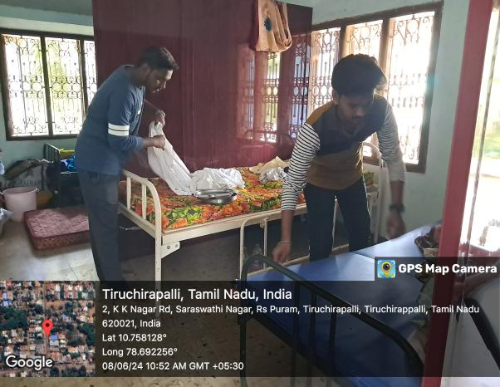

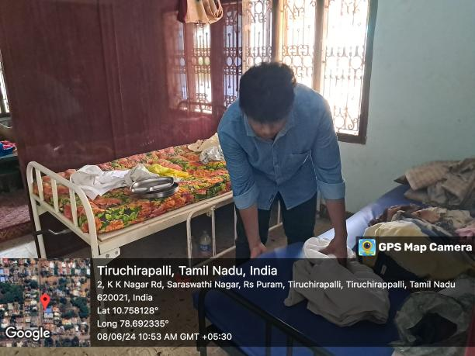

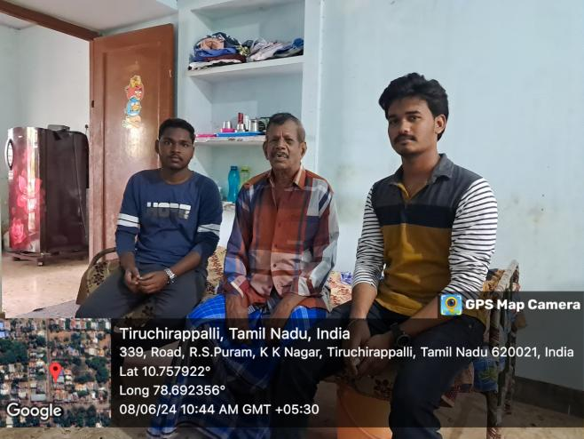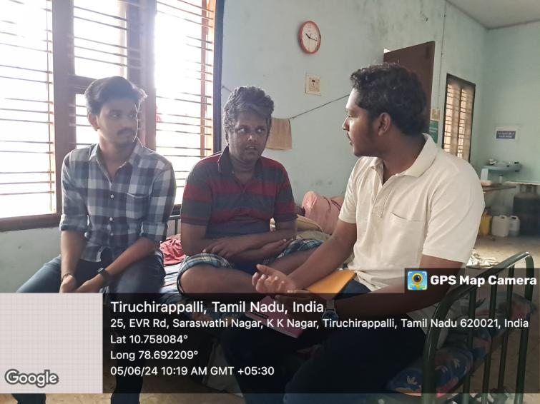

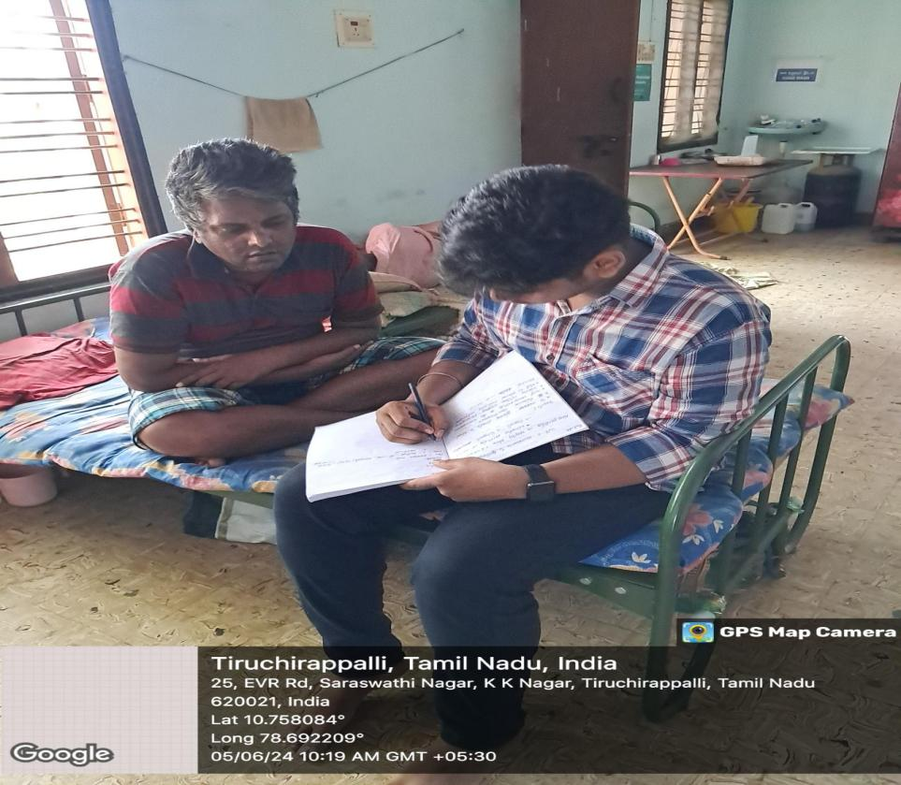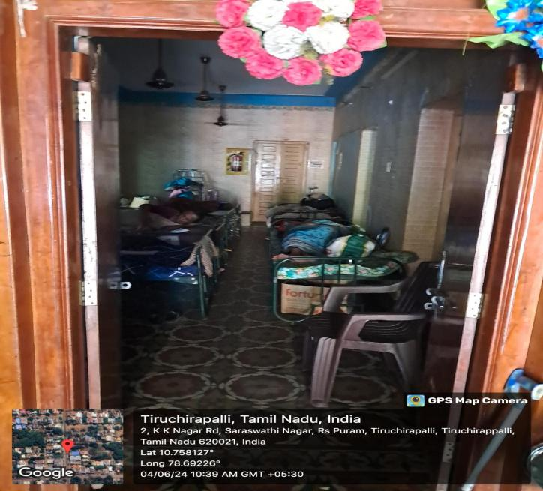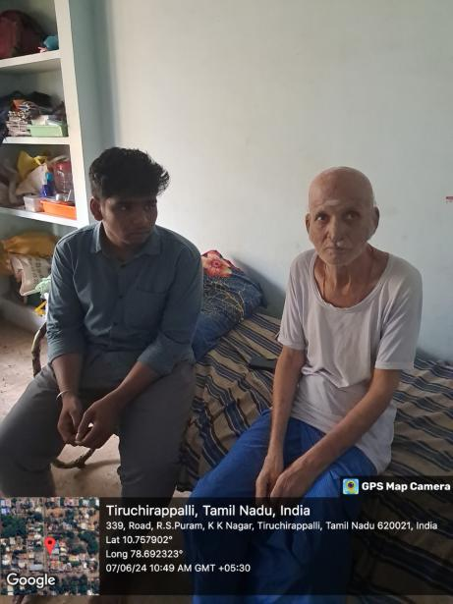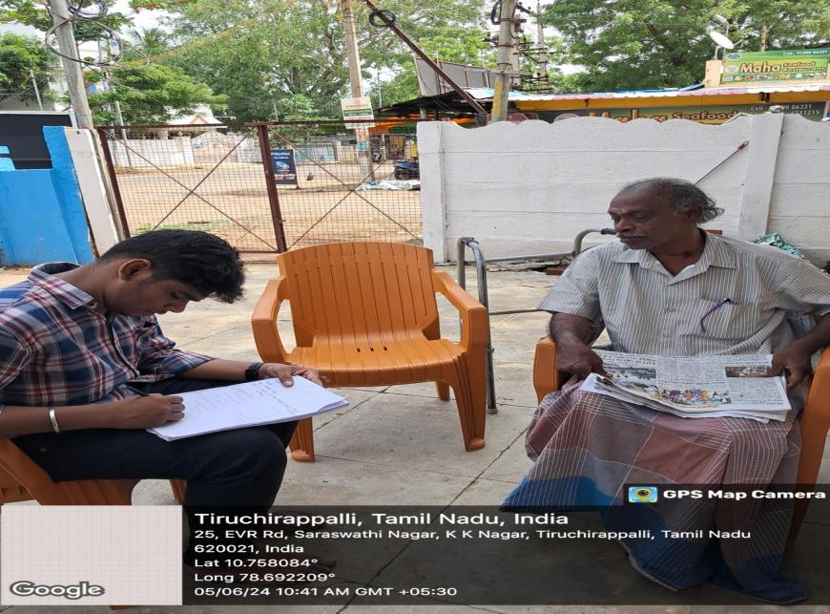

**4.2References**

1. Fall and Detection System using Intelligence-Based Edge Computing

Author:BOR-SHING LIN CHUEH-HO LIN 1,(Senior Member, IEEE), TIKU YU 2,CHIH-WEI PENG 4,5, HUNG-KAI HSU1, I-JUNG LEE 1,6, AND ZHAO ZHANG1,6,7, (Graduate Student Member, IEEE)

Year : January 4, 2022

Journal : IEEE Paper

1. A Real-time Fall Detection System Using ToF Depth Images

Author : [Rihui Li](https://ieeexplore.ieee.org/author/37089760244),[Dongxiao Li](https://ieeexplore.ieee.org/author/37535498700),[Ming Zhang](https://ieeexplore.ieee.org/author/37539174200)

Year : 09-11 December 2022

Journal : IEEE Paper

1. Research of Fall Detection and Fall Prevention Systems

Author : [Lingmei Ren](https://ieeexplore.ieee.org/author/37085531779), Yanjun Peng

Year :  13 June 2019

Journal : IEEE Paper

1. Fall Detection with Artificial Intelligence and IoT

Author : [Ana Pamela Castro-Martin](https://ieeexplore.ieee.org/author/37090078235)

Year : 10-13 October 2023

Journal : IEEE Paper

1. IoT Based Fall Detection System for Elderly Care

Author : [Yoanes Bandung](https://ieeexplore.ieee.org/author/37697743400) , [Luki B. Subekti](https://ieeexplore.ieee.org/author/38525206100) , [Tirza Fidela Bernadus](https://ieeexplore.ieee.org/author/37087321800)

Year : [2019 International Conference on ICT for Smart Society (ICISS)](https://ieeexplore.ieee.org/xpl/conhome/8964255/proceeding) on 19-20 November 2019

Journal : IEEE Paper